PMG201c-Final Practice Examination #2
Look at projects that you are involved with, have been involved with OR the projects going on around you. Select one project in your studying fields at FU (i.e software project for SE), give the solutions or answers for following requests based on your understanding about the project & assumptions
Request 1: give detailed description about the project which include project title, purpose, project objectives, success criteria, start/end date, and project milestones.
Request 2: identify 3 stakeholders and decide (with relevant reasons) if they are: High power or low power; High interest or low interest; Are they unaware of the project? Are they resistant to the project? Are they neutral? Are they supportive? Are they leading?
Based on your findings, design your strategy for how you would manage these stakeholders
Request 3: Go back to the three stakeholders you identified in the request 2. Create a communication plan that includes each of these stakeholders and the communications you believe they should receive. Each communication needs to include following information: information, purpose, frequency, method or format, responsible, review by.
Request 4: Assume that you have defined and estimate project schedule with below high-level activities
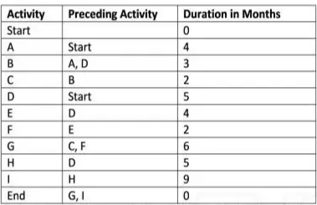
a) Use the critical path analysis technique to identify the minimum duration to complete this project
b) In the 8th week, you are executing the activity D and found that you need to speed up the project schedule to recover 3-week delay. Define 2 solutions with relevant explanation and assumptions (if needed) to achieve that (how it would help and difficulties/impacts to the project).
Request 5: Given the following information for a one-year project after 2 months since the project start, answer the below questions: PV (Planned Value) =$22,000; EV (Earned Value) =$20,000; AC (Actual Cost) =$25,000; BAC (Budget At Completion) =$120,000
a) What are the cost and schedule performance of the project? Show your calculations.
b) How is the project doing in terms of project cost and time (schedule). Explain about those statuses
c) Use the CPI to calculate the estimate the rest cost the team would need to complete the project.
d) Use the SPI to estimate how many months it will take the team to finish this project.

